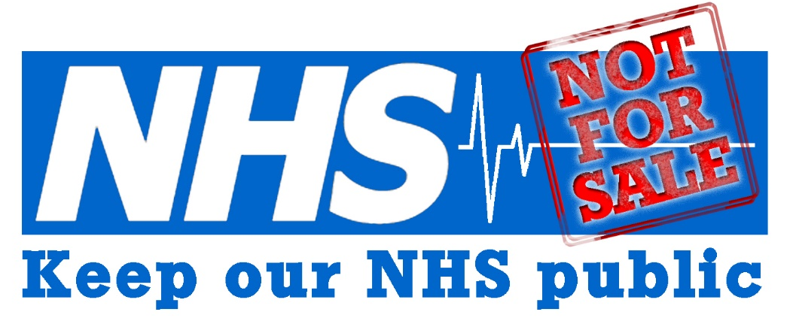
NORTH
EAST

"Keep Our NHS Public" Briefing Paper:
We need to be worried about the NHS Long Term Plan, Integrated Care Systems and
Primary Care Networks

The NHS Long Term Plan 2019 makes provision for sweeping changes in the NHS which are, ultimately, democratically unaccountable, unfunded, dangerously understaffed, and continue in a marketised, contract-tendering environment. In reality, the promise of extra money to the NHS to accompany the plan is simply not enough to repair the damage done by 30% reduction in funding since 2010 – it will certainly not meet the widely acknowledged, verifiable growth in need.

The Plan is full of optimistic proposals, yet local and national workforce issues have not been addressed. Changes are being introduced whilst staff are working at full stretch under huge workloads. The reality for the NHS is:
> over 100,000 NHS vacancies and 110,000 social care vacancies
> 10,000 NHS Trust doctor posts vacant PLUS the acute shortage of 5,000 GPs
> 40,000 nurse vacancies after the disastrous withdrawal of the NHS student bursary for nurses and other health professionals
> a crisis in Primary Care with the acute shortage of GPs and practice nurses
> Acute staff stress and burnout and higher rates of suicide amongst nurses
Without these workforce issues being seriously addressed, the ideas of the Long Term Plan are simply hopes and dreams without a basis in the current realities facing the NHS

On the Long Term Plan, we call for
>> National bodies to set out a clear set of responsibilities on how they will urgently expand a skilled workforce that can ensure that health and social care systems locally are quickly equipped with the tools and capabilities they need. NHSE must not absolve itself of national workforce planning responsibility by passing it down to ICSs
>> An end to the contracting out of services which are breaking up NHS continuity and quality of provision
>> Proper funding for the NHS. Despite being one of the richest countries in Europe, the UK currently spends less on healthcare than countries such as France and Germany.

The North East and North Cumbria Integrated Care System is conceived as providing services to more than three million people. It is subdivided into four Integrated Care Partnerships – North Cumbria, North (Northumberland, North Tyneside, Newcastle and Gateshead), Central (South Tyneside, Sunderland, North Durham, Durham Dales, Easington, Sedgefield) and South (Darlington, South Tees, Hartlepool, Stockton, Hambleton, Richmondshire, Whitby). We maintain that this macro Integrated Care System has financial management uppermost in its objectives, rather than patient need.
> the centralisation and merger have not involved formal public consultation
> Integrated Care Systems have no duty to be democratic as they have no statutory basis

> any future merger of CCGs saves money from the overall budget - but fails to compensate for loss of local democracy
> the resulting single ICS and CCG will be less accountable to democratic pressure, losing the scrutiny of local health planning for local patient needs by your local Council
> policies such as the rationing of care by limiting or ending access to specific NHS treatments and procedures will be decided across the NE and Cumbria with much reduced opportunity for vital local challenge and scrutiny
> ICSs will continue to use the contract processes which NHSE is committed to, leaving the NHS open to privatisation

On the Integrated Care System, we call for
>> the retention of local decision-making and democracy in health and local councils

Primary Care Networks are the answer from the Government in response to the crisis in General Practice – but what will it achieve? Stressed GPs are currently struggling to recruit medical staff, and face rising workloads and vacancies. Patients are waiting too long for appointments, do not see their preferred doctor, and lose continuity of care. Over half of GPs feel that they can no longer provide a safe service. A decade of financial neglect has damaged general practice. Funding has been reduced as a percentage of NHS funding, and instead of the promised 5000 more GPs, we currently have 1000 fewer GPs than in 2015. We have yet more costly reorganisations – the Government claims that it is helping GPs by funding new Primary Care Networks (PCNs) which will comprise additional non-GP staff but, welcome though that would be if it materialised, we still need more GPs. The extra 2% per year for General Practice nowhere near matches need. PCNs will be answerable to the Integrated Care System – not to local people. Risks include:
> the continued underfunding of core General Practice – whilst some money is promised, this will certainly not make up for the loss in real terms in GP funding over the last decade
> continued difficulty in recruiting and retaining GP staff, by diverting resources from core General Practice
> loss of autonomy and increased bureaucracy brought about by PCNs – especially if funding is funnelled through PCNs
> reduced accountability – PCNs need to be considered within the context of the wider loss of accountability occasioned by the development of Integrated Care Systems

On Primary Care Networks, we call for
>> a return to the principles of General Practice based on prompt access, personal relationships and continuity of care – proven to save lives
>> a significant increase to core funding in General Practice and a significant increase in the numbers of GPs and practice nurses. Funding for new roles in PCNs must not replace filling the 5,000+ GP doctor vacancies
>> PCNs must be NHS bodies, with staff on NHS terms and conditions
>>NHSE to consult the public about any plans to merge or close practices, including the creation of "super practices"; NHSE to provide impact assessments of such plans on travelling times and distances, availability of GP appointments, and continuity of care

Keep Our NHS Public North East comprises members of the general public, including some doctors and nurses. We meet in Newcastle and are an active campaigning group, open to all. We are not aligned to any one specific political party. More information and resources are found on our website.

Keep Our NHS Public North East
No cuts or cash-driven closures | Fair pay for all NHS staff | A fully-funded, universal, publicly owned and publicly provided National Health Service
konpnortheast@gmail.com
facebook NHSPublicNorthEast
twitter @KONPNorthEast
www.konpnortheast.com Oct 2019

