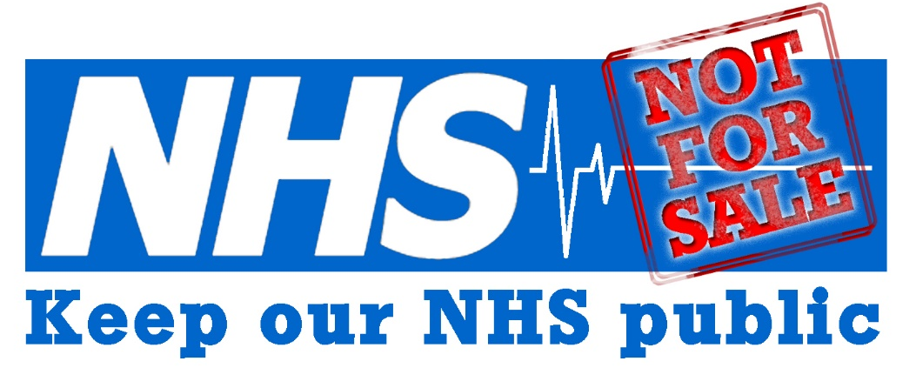
NORTH
EAST

"Keep Our NHS Public" Briefing Paper:
Accountable Care Organisations and
Integrated Care Systems

This briefing outlines how, as little as six years since the massive restructuring imposed by the Health and Social Care Act of 2012, the NHS is again undergoing radical change.

Changes by NHS England (NHSE) divided the English NHS into 44 local health systems or ‘footprints’ (‘Sustainability and Transformation Partnerships’). Each of these was required to integrate its local health services, and social care services where local authorities were willing, through cross-boundary working and pooled budgets.

As a result of further changes in 2017, Sustainability and Transformation Partnerships were then required to deliver ‘accountable care’ by morphing into what was known as "Accountable Care Organisations" (ACOs), now rebranded as "Integrated Care Systems" (ICSs). These are non-NHS bodies, ‘designated’ by NHSE, despite the absence of any statutory authority. Behind the rhetoric of superseding competition with collaboration, NHSE intends to replace multiple smaller NHS contracts with a single, long-term lead contractor for each region.

NHSE argues that introducing ‘accountable care’ (a term replaced by the more politically acceptable ‘integrated care’) is central to Government aims for the ‘financial sustainability’ of the NHS. In this context, ‘sustainability’ means reducing services to match insufficient funding. Despite being one of the richest countries in the EU, the UK currently spends less on healthcare than countries such as France and Germany. To close the gap between these countries and the UK would require an increase in spending of over 10%.

Accountable care systems (i.e. ACOs / ICSs) need to be opposed for the following reasons:
 They were introduced without adequate public involvement or meaningful consultation;
 They are being imposed in a context where NHS and social care services are seriously underfunded;
 They are being implemented beyond any legal framework, creating problems of governance and accountability;
 They are being introduced at pace, with no robust evidence base to support their use in the UK context;
 They increase the potential scope of NHS privatisation. For example, multiple procurements will be replaced by a single, major, long-term contract to provide health and social care services for an entire area. The draft model contract for ACOs published by NHSE allowed for bids from multinational corporations
 They will help strip NHS assets, such as land and buildings, so ending the social ownership of much of the NHS estate while allowing private companies to profiteer from it.
 They will enforce the unprecedented real terms shortfall in spending and transfer the NHS’s funding shortfall to new local, self-contained areas.
 They incentivise rationing of services and denial of care, and so are fundamentally at odds with social solidarity and the values of equity and universalism that underpin the NHS;
 They rely on unrealistic expectations, for example about collaboration and the sharing of risk and gain between private and NHS service providers.
 They entail ‘transforming’ the NHS workforce, replacing experienced clinicians such as doctors and nurses with technologies and introducing new, lower skilled roles, such as physician and nurse associates. They are likely to under-deliver required skill levels and undermine NHS terms and conditions of employment.

There is always room for improvement in most large organisations, and our acute, primary care and community NHS services and social care would benefit from increased integration. However, this does not require commercial contracts and the involvement of private business and multinational corporations.

A truly integrated system of health and social care requires:
a) Increased funding of the NHS and personal social care;
b) Personal social care provided on the same terms as health, free at the point of use and paid for from public funding;
c) Full and public involvement and meaningful consultation;
d) Robust piloting of future plans for integration and in-depth, independent evaluation; and
e) New legislation (see, for example, the NHS Bill: www.nhsbillnow) that protects Bevan’s founding principles of the NHS; ends the marketisation and fragmentation of the NHS; and re-establishes public bodies and NHS services that are accountable to Parliament and local communities.

--------------------------------------------------------------------------------------------------------------------------

This briefing paper is based on an original document by national Keep Our NHS Public.
This may be found at: https://keepournhspublic.com/campaigns/accountable-care/

Links to other materials about Accountable Care Systems / Integrated Care Systems are located at the local Keep Our NHS Public North East website page:
https://konpnortheast.com/stp-aco/

Keep Our NHS Public North East comprises members of the general public, including some doctors and nurses. We meet in Newcastle and are an active campaigning group, open to all. We are not aligned to any one specific political party.

Keep Our NHS Public North East
No cuts or cash-driven closures | Fair pay for all NHS staff | A fully-funded, universal, publicly owned and publicly provided National Health Service
konpnortheast@gmail.com
www.facebook/NHSPublicNorthEast
twitter @KONPNorthEast
www.konpnortheast.com

