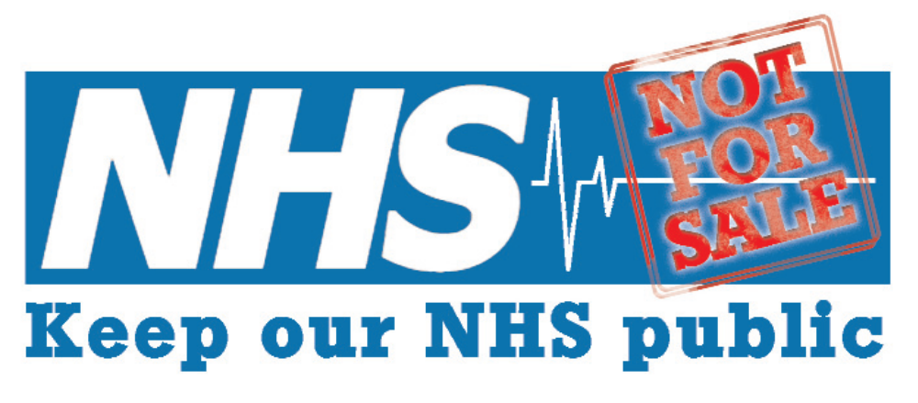
Keep Our NHS Public North East petition to CCGs and Local Authorities in the North East
I believe in a publicly funded, publicly provided and publicly accountable NHS, available on the basis of need.
I believe that access to high quality services is a right for all people.
I do not accept the underfunding of the NHS and social care, with the subsequent cuts to services in the North East.

I call upon the CCG and the Local Authority to be transparent about future plans, and the impact these will have on our NHS and social care services.
I demand that the CCG and Local Authority work to ensure that services are fully funded and that any future change to services in the North East are designed to maximise health and wellbeing, and are not financially driven.

