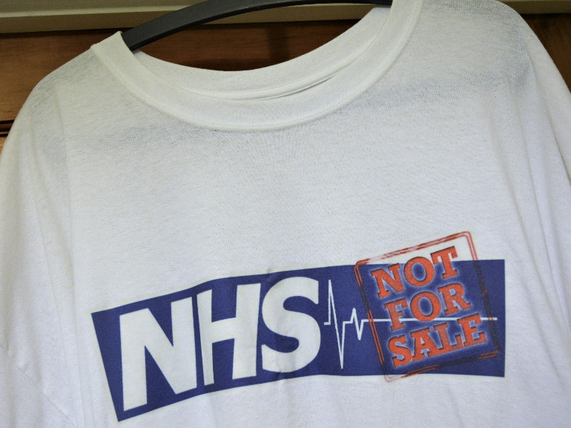
For all KONP supporters, family and friends:
Get the word out by wearing a
KEEP OUR NHS PUBLIC teeshirt
Many thanks to Phil at Newcastle's Logobear, who has very kindly offered to reduce the price of logo teeshirts as his way of supporting KONPNE….so instead of the usual Logobear price of £15.50 per teeshirt, Logobear will provide the white teeshirt and printing of the KONP logo for £10 all inclusive. This is very much appreciated.
Here's all we have to do:
> Go along to Logobear at 74 Clayton Street, Newcastle upon Tyne, NE1 5PG (opposite where the old "Woolworths" used to be), open Monday to Saturday, 9am – 5pm
> Choose the correct size of white teeshirt – S, M, L, XL, 2XL, 3XL – the tees are slimmer fit, so you are welcome to try one on to make sure
> The staff at Logobear have the KONP logo on file behind the counter - this will be printed A4 size on the chest
> Pay your £10, and your teeshirt will be ready to collect in one hour (or less) -easy…and quick! Thanks Phil!!
> If required, Logobear is also willing to post out teeshirts for £12 incl p and p – ring 0191 222 1138, giving card details and address, and hey presto!
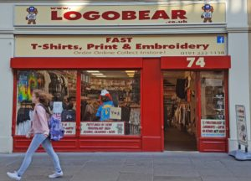
LOGOBEAR

