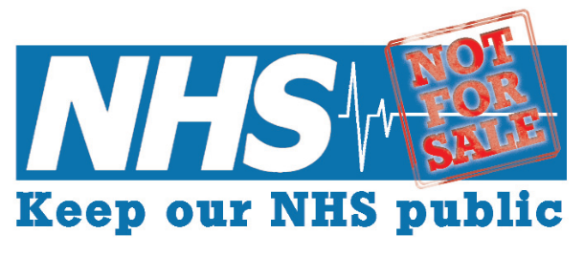
NORTH EAST

Notes of the meeting held on 7th July 2016 at Broadacre House, Newcastle
(1) Welcome to Keep Our NHS Public
John presented an update on Campaign activity since our previous meeting in March 2016. It has been a busy four months, and our work has included
- Participation in the planning of the Newcastle March for the NHS, involvement on the day, KONPNE speaker at the Rally at the Monument
- Joining with Junior Doctors on picket lines on three occasions at the RVI and Freeman Hospitals, in support of fair contracts for medical staff
- KONPNE attendance at the Rally in support of Junior Doctors, held at Brunswick Methodist Church
- Participation in the Newcastle anti-Immigration Act March, to highlight unfairness in health provision to migrants as laid down in the 2016 Act
- Attendance at CCG meetings
- Increased facebook activity
- Formation of a KONPNE Steering Group (additional new members are very welcome – please get in touch)

(2) NHS Privatisation – past, present and future, including an overview of the Governments ‘Sustainability and Transformation Plans’
Nick Dowson (National Health Action Party) presented an overview of NHS privatisation over recent years, and reviewed the main components of the latest step in privatisation – ‘Sustainability and Transformation Plans’. More information about this development can be found at http://999callfornhs.org.uk/footprints/4592357931
Discussion at the meeting centred around uncertainty about STP proposals for the North East, lack of information about public consultation, where is the space for public representation on this body, accountability issues (how is this amalgamation of organisations accountable, and who is it accountable to), what is the legal basis of this organisation, and the fact that there appears to be a focus on economics rather than health.

(3) Update on the Junior Doctor contract
Dr Pete Campbell provided feedback on issues related to the Junior Doctors contract. There remains much dissatisfaction with this contract, and it appears that further action will ensue. Pete will keep members informed of developments and possible ways in which we may support Junior Doctors

(4) Immigration Act 2016
Discussion around the health provisions to migrants, as laid down in this year’s Immigration Act. There is an expectation of checking of immigration status by NHS staff, and subsequent restriction of access to healthcare if specific conditions are not met. KONP supports decent healthcare for all – indeed recognises the specific needs of people who are seeking asylum.
The meeting was attended by members of the local group “The Migration and Asylum Justice Forum” – KONPNE attended a recent March to highlight the unfair provisions of the Immigration Act 2016, and MAJF highlighted a further national day of action on Saturday 13th August – details to be announced by MAJF.

(5) Campaigning over the summer 2016
John suggested ways of maintaining Campaign momentum over the summer period. These included:
- Emailing your MP to ask about his/her involvement with the NHS Reinstatement Bill. The email address of MPs can be found at www.parliament.uk/mps-lords-and-offices/mps. Consider following up the email with discussion at a constituency surgery; all MPs have constituency websites, which provide the times and location of these informal meetings.
- Please comment / like / share our facebook postings at (www.facebook.com/NHSPublicNorthEast), and feel free to use our page as an opportunity for communication and debate. We need to get the word out far and wide – and sharing our facebook takes ONE MINUTE MAX.
- Get involved with our friends at 38degrees and Change.org – we need to join with others, so that our voices are heard. Consider writing to the letters page of your local paper.
- Keep an eye on local and national developments eg local contracting out of services, hospital closures, cut backs, and how the NHS Sustainability and Transformation Plans is affecting local services. Be aware of and support specific campaigns (eg: Junior Doctors Contract, Nurse Bursary Cuts, impact of the Immigration Act on health provision). Attend Clinical Commissioning Group meetings (for your locality) and Patient Participation Groups (for your GP practice). Above all, MAKE YOUR VOICE HEARD!!

Everyone was thanked for attendance.
The date and time of the next meeting will be confirmed after liason with speakers. We aim to meet up four or five times per year, with email and facebook contact in-between meetings.

John Whalley
Keep Our NHS Public North East
6th August 2016

